|  |  |
| --- | --- |
| A picture containing person  Description automatically generated  LIMINALVR Project1  Documentation 2 | Abstract  The experience is to be designed for Oculus Go. We need to integrate the points of interactions with the use of controller’s trigger or touch surface as inputs. This project relies heavily on UX, so we are advised to conduct a UX testing at the end of each sprint using proper testing techniques. The learning from the UX testing, should be incorporated in next sprint of development.  Ajit Ghising, Dawa Zangmu Sherpa, Dipendra Poudel, Dinesh Aryal Group 2  ITECH3208 |

# Executive Summary

The project is based in organization which has developed procedures intended to improve quality of life using different kinds of virtual reality experiences. As we know that virtual reality is that experience which is completely different from the real world which is very interesting to all the teenage students as they can feel different experience behind the real world.

So according to the team discussion we came up with the idea that the project will be based on seeks to create an experience to ‘wake’ them up and get them motivated to ace the test! For this project we are going to use various development tools such as Blender ,Unity, GitHub and Audacity which will result in the succeeding of our Liminal VR project, which not only includes the Virtual reality video that is exciting but it also going to make viewer energetic.

A Work Breakdown Structure, Gannt chart and Milestone plan have been created to outline project tasks and the expected timelines. These diagrams also assign team responsibility. Key dates include:

* Requirement analysis due by 1st September 2019
* Design due by 1st September 2019
* Testing due by (Nest Semester)
* Audio due by (Next semester)
* Coding due by (Next semester)

Project risks have also been considered and listed. Each item has a mitigation action assigned. Some of the potential risks include:

* Conflict between team members
* Ill-defined scope (Leads to conflict, rework, and stakeholder dissatisfaction)
* Lack of change management process
* Inadequate design

A tasks list has been created to assign and track completion of team member individual tasks.

A regular meetings schedule has been established which will be used throughout the project to ensure clear and constant communication between the team, client and Manager. Team Members are using the various type of social media to discuss the project progress in a group where everyone is connected 24/7. Members are also using the collaboration tool [GitHub](https://github.com/login) to see progress of each team members. Examples of team communications have been included in an appendix.

The project plan is a detailed list of project tasks, resources and timelines and enables the team and supervisor to track progress against expected dates and effectively manage risks.

Contents

Executive Summary 1

Introduction 3

Summary 3

Group Details 4

Team/Studio Name 4

Team Members Names (email & phone): 5

Meeting times 5

Project Responsibilities 7

Name of Education Partner (if applicable): 7

Category of experience (i.e. Calm or Energy): 7

Total estimated development time (in hours): 7

Creative Concept 8

Working Title of Experience: Jurassic world VR experience. 8

Synopsis of Experience: 8

Long Description: 9

Reference to psych docs and/or other research: 13

Reference images: 13

Appendices 17

Questions: 19

# Introduction

## Summary

The experience is to be designed for Oculus Go. We need to integrate the points of interactions with the use of controller’s trigger or touch surface as inputs. This project relies heavily on UX, so we are advised to conduct a UX testing at the end of each sprint using proper testing techniques. The learning from the UX testing, should be incorporated in next sprint of development.



Liminal VR Pty Ltd (ABN: 95 604 859 289)

Suite 1.04, 17-19 Yarra Street, Abbotsford, Vic 3000

[www.liminalvr.com](http://www.liminalvr.com)

**Liminal Platform – Creative Concept Template**

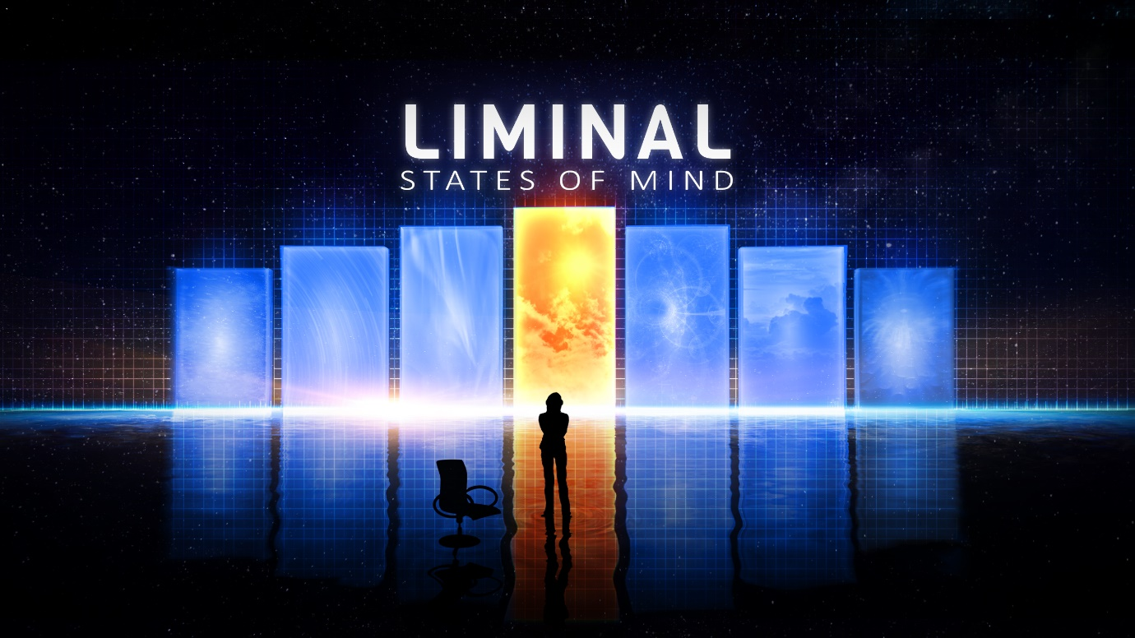

“Thank you for being a Liminal Partner! The purpose of this document is to give the Liminal Team an overview of your team and the experience you are creating. This will help us give early feedback to help you hit the ground running and maximise your chances of your experience being published on the Liminal Platform.

Before completing this document, please ensure that you have read the following:

* The Liminal Developer Wiki (<https://github.com/LiminalVR/DeveloperWiki/wiki>)
* The Psych Docs ([www.liminalvr.com/psychdocs](http://www.liminalvr.com/psychdocs))
* Liminal Partner Agreement ([www.liminalvr.com/terms](http://www.liminalvr.com/terms))

If you have access to an Oculus Go or Samsung Gear VR, we’d also encourage you to try some of the experiences on the Liminal Platform. “

# Group Details

**Date:** 29/09/2019

Team/Studio Name**:** Team1/Group2

## Team Members Names (email & phone):

|  |  |  |  |
| --- | --- | --- | --- |
| Team Member | Phone | Email | GitHub ID |
| Ajit Ghising | 0406247815 | azit.ghising@gmail.com | azit.ghising@gmail.com |
| Dawa Zangmu Sherpa | 0452658651 | dawazangmus@gmail.com | dawazangmus@gmail.com |
| Dinesh Aryal | 0405113321 | dinesharyal000@gmail.com | dinesharyal000@gmail.com |
| Dipendra Poudel | 0451874115 | connectdepen@gmail.com | connectdepen@gmail.com |

## Meeting times

|  |  |  |  |  |  |  |
| --- | --- | --- | --- | --- | --- | --- |
| **Meeting Type** | **Length** | **First Meeting** | **Frequency** | **Number of Planned Meetings** | **Location/Mode** | **Objective** |
| **Team Meeting** | 12pm to 2pm | Friday  30th July  2019 | Weekly | 1 | ATMC | Group formation & Discussion |
| **Client Meeting** | 10am to 11Am | 07/08/2019 | Bi-weekly | 2 | Atmc lab | Discuss about requirement of the project |
| **Client Meeting**  **(Week 3)** | 10am to 11am | 07/08/2019 | Weekly | 4 | ATMC Druitt Street | Chat over phone by Damian |
| **Client Meeting**  **(Week 5)** | 10am to 11am | 11/08/2019 | Weekly | 6 | Atmc room 4 | Gathering of group and discussion of requirement |
| **Client Meeting**  **(Ongoing)** | 12am to 2pm | 20/08/2019 | Weekly | 13 | ATMC | Requirement and need for luminal VR |
| **Technical Issues VR** | 10 am to 11 am | 07/09/2019 | 2 weeks gap | 2 | ATMC lab 6 | We were having problem in experiencing VR due to technical issues. |
| **presentation** | 9 am to 10 am | 14/09/2019 | weekly | 2 | Atmc Library Room | We came up with group work again and deal with all the confusion with different ideas. |
| **work on iteration document 2** | 9 am to 10 am | 14/09/2019 | weekly | 2 | Atmc Library Room | After diving task, we need to start one more individual report. |
| **Experiencing Oculus Go** | 12 pm to 2 pm | 17/09/2019 | weekly | 3 | Atmc George street Campus | Got real experience of oculus GO VR |

## Project Responsibilities

Name of Education Partner (if applicable):Federation University ATMC Campus, George street, Sydney NSW

Category of experience (i.e. Calm or Energy):Calm

# Total estimated development time (in hours):

|  |  |  |  |
| --- | --- | --- | --- |
| Task | Best time (OD) | Worst Time (PD) | Estimated time (ED) |
| Choosing Experience | 30 min | 40 min | 20 min |
| Synopsis of experience | 45 min | 55 min | 25 min |
| Finding Website | 15min | 25 min | 20 min |
| Going through the psych docs | 40 min | 60 min | 30 min |
| Writing a creative concept | 200 min | 240 min | 180 min |
| Choosing platforms to develop | 50 min | 90 min | 30 min |
| Making good report | 30 min | 35 min | 25 min |
| Referencing the report | 15 min | 20 min | 5 min |
| Total | 425 min | 565 min | 335 min |

D = ((1 * OD) + (4 * ED) + (1 * PD))/6

= ((1 * 425) + (4 * 335) + (1 * 565))/6

= (425 + 1340 + 565)/6

= 2330/6

= 388.33 mins (6.47hrs)

**Project start date:** 05/07/2019

**Final delivery date:** Unknown

# Creative Concept

We have chosen clam experience for the liminal VR project where clam state is identified as an emotional and cognitive demission i.e. Jurassic world. the clam experience that we choose to create for the liminal platform is aimed to 3 minutes in length where the environment is the Jurassic world where the user calming experienced are passive in nature.

## Working Title of Experience: Jurassic world VR experience.

### Synopsis of Experience:

we are going through a passive approach, users should be sitting or lying still because passive VR is well suited for deep relaxation purposes users need to do so. The key of this experience is constant progression and evolving content by maintain the engagement with users in experience. for this we are implementing “nature” which is one of the clam principals and technic.as it is the passive experience (Jurassic world) both real and digital interaction with this Jurassic nature can be extremely beneficial for relaxation, stress relief also reduce cognitive fatigue. The calming natural element of this Jurassic world contain;

* 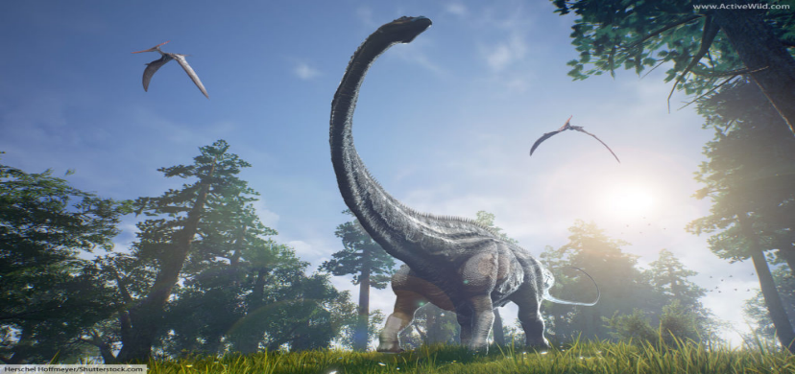sun beams shifting through leaf.
* tree branches blowing gently in breeze.
* view of trees and forest
* field dominated with grassland.
* park like forest creek.
* mountain with waterfall or steam.

Our experience contains the above listed natural element on based which the design factor will be 360 (field of view).

### Long Description:

For this project we are going to use various development tools which will result in the succeeding of our Liminal VR project, which not only includes the Virtual reality video that exciting but it’s also going to make viewer energetic.

For Jurassic world project, we are going to use various software:

* GitHub: As we know that GitHub is a development platform, we are going to use GitHub to upload the activity and review the work we teammates are doing as well to manage the project we are working on.

Overall, we are going to use this platform to look over the progress and drawback of the project and try to eliminate it. 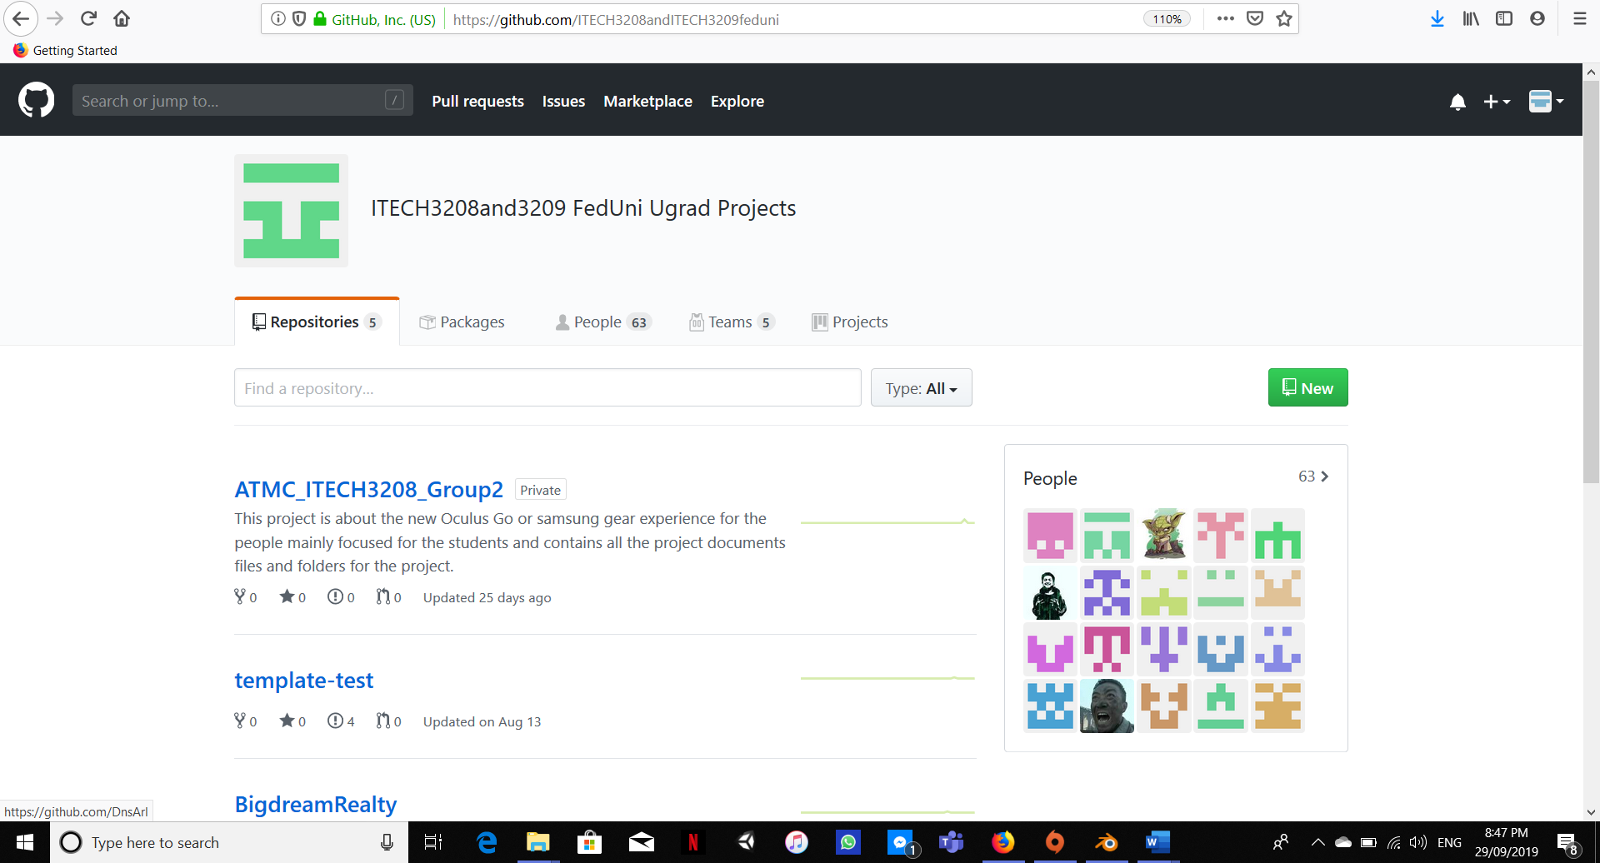

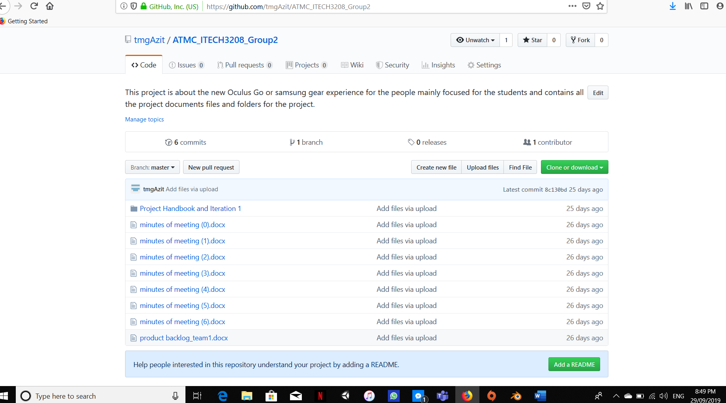

* Blender: Blender is going to play a very big role in our project. It will be widely used by our team to make various things in Jurassic world. As we have described earlier about the dinosaurs, sunbeams, tree and visual forest that looks like reality when looked over it by using virtual reality device.

Overall, we are going to use blender for creating 3D printed model, Graphic editing, partial stimulation which will help us to make our model into reality i.e. Dinosaurs, Trees, sun and its beams which will be later uploaded into unity.

* Unity: As we know that Unity is ultimate game development platform which is usually used to make 2D as well as 3D games which can not only be deployed into PC and phone but also over VR console so our team has decided to use Unity to make video for our project. Ricky and Morty, Ori and the Blind forest is quite popular video as well as game so seeing that we got a influence and decided to make our Jurassic world experience over it.

Hence, the model we will made over the Blender i.e. Dinosaurs, trees, bushes as well as sun will be uploaded over it and we will do coding to make the functionality work into it.

* Audacity: We are going to use Audacity to performs various number of audio editing tasks such as to make music that will put a life into the Jurassic world project. That will make views to feel like they are inside that video they are looking and feel them energetic.

Overall use of this various platforms will help us to get our project to be successful, we will have an environment which is fully being in a nature as provide the viewer refreshment as well as energetic.

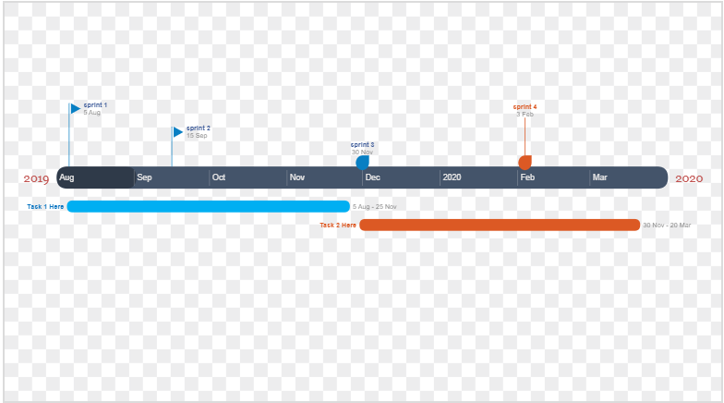

### Reference to psych docs and/or other research:

i.e. Slow linear motion used for falling snowflakes [psych docs: Motion Section

Muted blues and greens used for environment [psych docs: Colour]

# Reference images:

We might be creating the design like the following images in upcoming days.

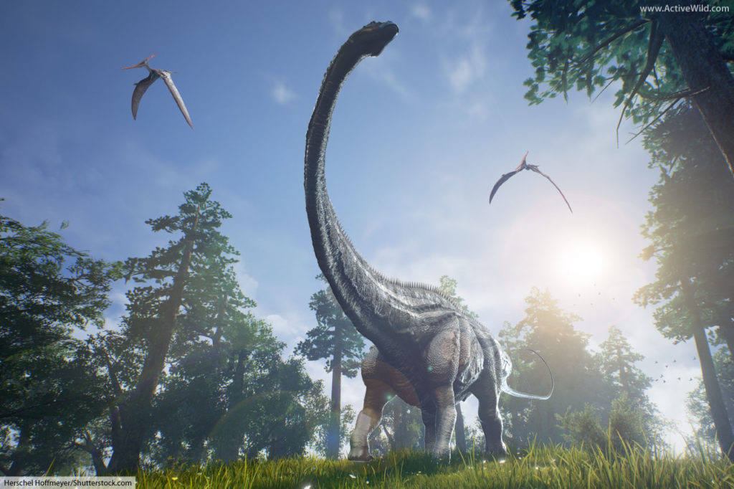





# Appendices

Email dawazangmus@gmail.com

|  |  |  |
| --- | --- | --- |
| Date: 07/09/2019 | Start time:10am | End time:11am |
| Venue | ATMC Lab 6 |  |
| Present | All group members |  |
| Issues | Decision | Issued by |
| We were having problem in experiencing VR due to technical issues. | After meeting with the co Ordinator we were able to use VR next week. | Dawa Zangmu Sherpa |
| We had to prepare class presentation based on project. | We start to work on presentation based on the task that we have divided | Dawa Zangmu Sherpa |

Email dawazangmus@gmail.com

|  |  |  |
| --- | --- | --- |
| Date: 14/09/2019 | Start time: 9am | End time:10am |
| Venue | ATMC Library room |  |
| Present | All group members |  |
| Issues | Decision | Issued by |
| After presentation we need to work on iteration document 2 | We came up with group work again and deal with all the confusion with different ideas. | Dawa Zangmu Sherpa |
| After diving task, we need to start one more individual report | we started working on it and got some few ideas and concepts from lecturer as well | Dawa Zangmu Sherpa |

**Minutes of meeting Meeting holder: Dipendra poudel**

**RECORD OF MEETING**

**NEXT MEETING: 28/09/2019**

Recorded by Team1(ITECH3208)             email: connectdepen182@gmail.com

|  |  |  |  |  |  |
| --- | --- | --- | --- | --- | --- |
| Date: | 17/09/2019 | | Time: 12:00 pm | | Closed: 2:00 pm |
| Venue: | ATMC George Street, campus | |  | |  |
| Topic: | Discussion about the experience of oculus GO VR for the project and prototype of the project | |  | |  |
| DISCUSSION | | DECISION: | | ACTION BY: | |
| 1.Got issue while configuring oculus GO VR for the experience. | | We got oculus GO VR for experience but can’t configured properly so we went to IT assistance person (Gaurav Shrestha) to fix the configuration of oculus GO VR. | | Team1(ITECH3208) | |
| 2.Discuss on the various part of the project protype. | | We discuss about the various part of the project prototype and decided to divide the tasks to each member of the group. | | Team1(ITECH3208) | |
| 3.Got real experience of oculus GO VR | | After configured oculus GO VR properly. So, we got real experience of virtual reality. Which help us to generate various types of ideas for the project prototype. | | Team1(ITECH3208) | |

# Questions:

If you have any specific questions about your creative concept at this stage, feel free to ask them here or contact Damian Moratti at [damian@liminalvr.com](mailto:damian@liminalvr.com) or 0416 077 344.

If you have a more general question, please feel free to use the Liminal VR Partners Slack channel.